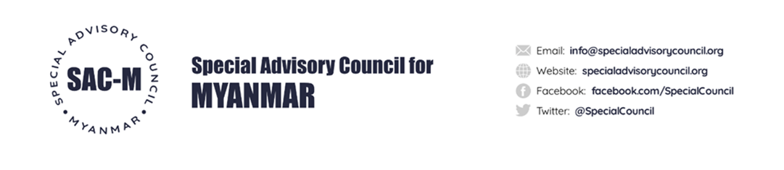

9 January 2022

To whom it may concern,

We are the Special Advisory Council for Myanmar (SAC-M), a group of independent international experts and former United Nations (UN) mandate holders on Myanmar.

As you will know, the Myanmar military attempted to seize power in Myanmar by staging a coup in February 2021. Since then, the military junta has continued to commit gross human rights abuses against the civilian population in Myanmar, including by targeting and killing peaceful demonstrators, indiscriminate shelling in civilian areas, massacre, arson attacks, torture and execution. These violations have resulted in the killing of large numbers of civilians, including children, and have been classified as potential war crimes by authoritative UN mechanisms such as the Independent Investigative Mechanism for Myanmar (IIMM).

While the Myanmar military is able to purchase weapons from foreign suppliers, it also manufactures a large quantity of weapons itself in country. These weapons – made at so called KaPaSa factories under the supervision of the Myanmar Directorate of Defence Industries (DDI) – have been identified by SAC-M as having been used by Myanmar’s armed forces prior to, during, and after the attempted coup to commit gross human rights abuse, war crimes and possible acts of genocide.

Over the past year, SAC-M has mapped out the Myanmar military’s weapon manufacturing in the country, with a view to identifying suppliers of products – including transfers of technology and know-how, raw materials, parts and components, end-items as well as technology and machinery – needed by the DDI to manufacture weapons at scale.

SAC-M’s report, attached to the present letter, identifies a large number of companies domiciled in various jurisdictions that appear to have supplied, or continue to supply, the DDI with products needed to sustain weapon manufacturing in Myanmar. According to credible information received by SAC-M, the provision of many of the identified products may be taking place in contravention of international export controls and other restrictive measures that currently apply in relation to Myanmar, the Myanmar military and companies associated with it. SAC-M has also identified a large number of Myanmar-based companies that, acting as front companies for the Myanmar military, appear to be enabling deals for the DDI for the manufacturing of weapons in the country.

We are contacting you, because your products / services have been identified in our research as being used by the DDI in Myanmar for the manufacturing of weapons.

We invite you to respond to the findings of the report. All responses by companies and their home States identified in the report will be made public on SAC-M’s website, together with this letter and the report itself.

In particular, we invite you to respond to the following questions:

- How have your products/services ended up at KaPaSa factories for the manufacturing of weapons in Myanmar?

- What, if any, export control permits have you obtained for the export of the products / services identified in the report?

- What are your current due diligence practices to identify and assess the human rights impacts of your products / services, especially when they are used in conflict-affected areas such as Myanmar?

- What actions have you taken, or do you intend to take, to address the risk that your products / services end up in use by the Myanmar DDI for manufacturing of weapons? Specifically, what are the contractual and technological means available to you, and with regard to the leverage you can exert over dealers, agents, and others with whom you have a business relationships, to address the findings in SAC-M’s report and how do you intend to make use of such measures?

- What are your public commitments to respect human rights and create robust human rights due diligence policies and processes connected with the use of your products and services, including via your business relationships?

- How do you consult with stakeholders in relation to the actual and potential human rights risks arising from your activities and from the activities of those with whom you have business relationships?

Thank you for your consideration on this matter.
Faithfully,
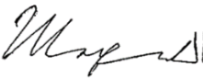

Yanghee Lee Marzuki Darusman Chris Sidoti
Special Advisory Council for Myanmar

